Volume 1, Issue 1

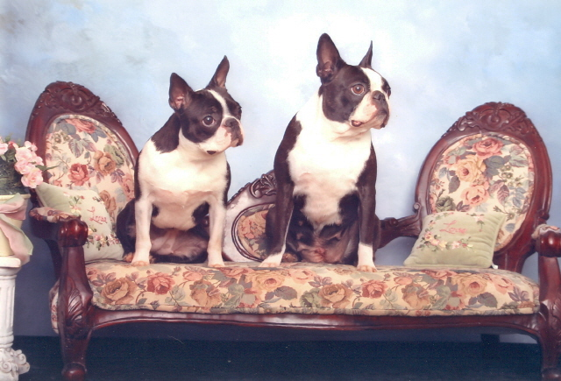
Mississippi Canine Coalition, Inc.
NEWS FLASH! NEXT MEETING: NOV. 3RD, 2007!!!!!

Welcome to the first Ms. Canine Coalition, Inc. Newsletter!

What is Mississippi Canine Coalition, Inc. (MCCI)?
The purpose of MCCI is for dog owners to assist or participate in local, state, national legislation concerning dogs and dog owners: To bring such legislation to the attention of the members of the general public; To promote responsible dog ownership; To use all legal means to promote the general welfare of dogs and dog owners and to disseminate information and knowledge regarding dogs. We are a non-profit organization.

CHECK OUT OUR NEW WEB SITE:
http://www.mississippi-canine-coalition.org

Newsletter Date: Sept. 27th, 2007

NEXT MEETING:
The annual meeting of the Mississippi Canine Coalition, Inc. will be held on Saturday, November 3, 2007, at the Local Branch Library, 4912 Old Canton Road, Jackson, MS. It will start at 1:30 pm.

COME JOIN US! WE WOULD LOVE TO MEET YOU AND TALK TO YOU!
What is Breed Specific Legislation (BSL)?
Several people and organizations have been trying to ban certain breeds of dogs in their community, county, state. Some of these breeds my include the pit-bull or pit-bull mix, Rottweilers, Terriers, and several other specific breeds. However, it is a known and documented fact that it is not the breed of dog but how the dog was trained, cared for and socialized that makes a difference in the animal’s behavior. By making a BSL, it is not going to solve dog bites or attacks. The American Veterinary Association and several other State Veterinary Associations are on record opposing breed specific legislation. Often it is the owner, not the dog responsible for lack of training or for the inappropriate behavior of the dog. Dog owners need to be responsible for their dogs. Untrained and unsupervised dogs of any breed or mixed breed can cause havoc in any neighborhood. The key is not banning specific breeds but thoroughly training these dogs, nuisance ordinances, and responsible dog owners. Some of these breeds or breed mixes serve as valuable community members by assisting as therapy dogs, search and rescue dogs, drug sniffing dogs, police dogs, and companions for the elderly. So, the solution is not breed ban legislation.
Written by: Rhonda Foles

Who Can Join??? You can. Come on…….

Our organization is open to anyone who wishes to support the coalition objectives. There are IV levels of membership based on your eligibility and approval.
Type I: Delegate Member Open to all Kennel Clubs, Specialty Clubs, Obedience Clubs, Agility Clubs, and independent dog fancier organizations.
Type II: Individual Member Open to all individuals.
Type III: Sponsor Member Open to all professional, commercial, educational, and non-profit organizations and individuals.
Type IV: Associate Member Open to individuals who are not residents of the state of Mississippi.
For inquiries regarding membership, please submit to: arcadiankennels@bellsouth.net Care of Rhonda Foles, Corresponding Secretary for MCCI

PAGE 1

